Project On
Hostel Management System
K.S.K.W. Arts, Science and Commerce college, Cidco, Nashik.
(T.Y.B.SC 6TH SEM)

Designed and Developed By :
- Hemant Vithoba Gangurde (07)
- Sagar Sanjay Endait (05)

Project Guide :
Prof. A.D.Bhandare


K.S.K.W. Arts, Commerce & Science College, Cidco, Nashik - 8.
Department of Computer Science
ACADEMIC YEAR 2021-2022.

CERTIFICATE

This is to certify that the Project Title "Hostel Management System" has been successfully
completed by: Hemant Vithoba Gangurde and Sagar Sanjay Endait in partial fulfilment of the requirements of Third year B.Sc. Computer Science to Savitribai Phule University for the academic year 2021-2022.

Project Guide: Prof. A.D.Bhandare Head of the Department:

Internal Examiner: External Examiner:

INDEX
- Acknowledgement
- Introduction
  - Existing System
  - Proposed System
  - Scope of the System
- Feasibility Study
- Requirement Specification
- System Design
  - Er Diagram
  - Class Diagram
  - Sequence Diagram
  - Use-Case Diagram
  - Activity Diagram
  - Sequence Diagram
- Conclusion

ACKNOWLEDGEMENT
We own our sincere gratitude to all those people who have given us their constant support and encouragement without which our project report would not have reached this stage.
We would like to express our thanks to (HOD NAME), HOD, (Department name), for his/her advice and encouragement. He / She has been a pillar of strength right through the project till the preparation of this report and helped by boosting moral support and the infrastructure they provided to us.

INTRODUCTION
The Hostel Management System is designed from a user point of view. The System provides platforms for Admin to update student records, process payments and store payment and student data in database. Admin has all rights reserved to all types of operations like View, Insert, Update and Delete Customer Information. Admin provides facilities to the student for booking room, paying rent and deposit.
The important benefit of this Proposed System is that it has user-friendly design that helps the user in booking hostel room online with ease. Attempts have been made to keep the design simple and understandable.
Hostel Management System involves identifying, acquiring, allocating and tracking the Student Data. Student must be authenticated to Book room, pay deposit and pay rent through the system login.
A Hostel Management System is referred to as a set of detail methods that is used to handle the appointment scheduling process. Providing deposit and rent details can be computerized. That helps the student to book room online in an efficient manner.
Hostel Management System can help improve Hostel’s capability to analyze & understand the difference in it’s student’s behavior, preferences, habits and thus creating opportunities to serve them better.

OBJECTIVE OF SYSTEM
The main objective of the “Hostel Management System” is to keep track of student data. The main features of the “Hostel Management System” are,
- To book rooms, rent and pay deposit quickly
- To make it convenient for people who have limited time.
- Cost Reduction
- Reduce paperwork
- Computerized renting and depositing system
- Centralized reporting system for Room allotment and deposit payment for student.
- Availability 24x7, Student can book room any time.
- More visibility across geographical location without physical presence.

Existing System
The existing system happens to be a non-computerized operating system where all operations are done manually by the salesman, orders are placed manually and the student has to travel physically, but there are many disadvantages to this system, including the inconvenience of the student needing to have a physical presence, the necessity for the hostel to have Warden answering and booking rooms and accepting deposit payments manually. In this method time and manual work is required.
The existing system is not capable to analyze & understand the differences in it’s student’s behavior, preferences, habits and needs and thus create opportunities to serve them better.
Due to manual means being employed by the hostels, it is very difficult to satisfy the wants and needs of the students.
Most of the problems include :
- Mistakes are made when booking the rooms and making deposit payments.
- The process of preparing and maintaining deposit payment and rent data is very tedious.
- It leads to lack of understanding between the student and the hostel staff.
- Delay in processing the payments.
- The record keeping system is poor. Losses of vital records have been reported in the past consequently. Besides, protecting the file system from unauthorized access is a problem that has been defiled solution.
These are major problems faced by the existing system and would be corrected with the help of the proposed system.

Proposed System
The proposed system is developed to manage deposit payment activities for hostel. It helps to record customer submitted orders.
For each student special webpage is designed and each student can signup in the system and login using their email address or phone number and password to access their account.
Encourage more students to book rooms in the hostel by offering various facilities in the rooms like beds, fan and table,etc. Recognize students who pay rent on time.
The system should cover the following functions:
- To allow the student to book rooms before visiting the hostel.
- To provide an interface that allows quick and easy room booking.
- Tools that generate reports that can be used for decision making in maintaining room services.
- A tool that allows the Hostel Management System to Modify the student information such as.

Scope of the System
The main advantage of this system is that it greatly simplifies the room booking process for both the student and the hostel. When the student visits the Hostel Management System, they would be presented with an interactive and up-to-date service list, complete with all available option and dynamically adjusting prices based on selected option. After making a selection, the service is then added to their profile, which the student can review the details. This provides instant visual confirmation of what was selected and ensures that services are, in fact, what they were intended.
This system also greatly lightens the load on the hostel and warden’s end, as the entire process of booking room is automated. Once a room is booked on the system, it would be entered into the database and then retrieved; in pretty much real-time on the hostel within this application, all student details in the booking would be displayed, along with their corresponding options, in a concise and easy manner. This allows wardens to quickly go through the bookings as they are booked and provide the necessary services with minimal delay and in their working timing.
This system would enable the end users to Register Online, select a tenure for renting the room. The results after selecting the date for the rent tenure would directly appear in the admin’s dashboard.
By using this system, the work of the receptionist is reduced and we can also say that the work is nullified. The benefit of this is that if there is a rush in the hostel then there will be chances that the receptionist will be unavailable and the students can directly book rooms online by using the system. This system would help the hostel in maintaining student relation in a better way . The student would get a username and a password after registration. This implies that the student is a regular user of the system.
Manual system involves paper work in the form of maintaining various files and manuals. Maintaining critical information in the files and manuals is full of risk.

ADVANTAGES
- This system would reduce the human errors.
- Usage of this system would greatly reduce time.
- Accuracy in handling of data would improve.
- The volume of paperwork will be greatly reduced.
- Fast rate of operation as in booking the room and deposit payment methods.
- Flexibility of time and place for the student and admin who happen to be the end user of the system
- Better storage of student records and faster retrieval of student medical history system.
- Errors in the reports would be greatly minimized

FEASIBILITY STUDY
- Feasibility is the determination of whether a project is worth doing.
- This process followed to determine this is called Feasibility Study
It includes :
- Operational Feasibility
- Economic Feasibility
- Technical Feasibility

- Operational Feasibility :
It determines whether the given system will be used if developed. The proposed system is Operationally Feasible as it provides easy access to user who uses the system. No training is required to train the users as it is User-Friendly and easy to use and even users need not be a professional.
- Economic Feasibility:
It is most frequently used method for evaluating the effectiveness of the development system. It is also a cost benefits analysis. The procedure is to determine the benefit and saving that are expected from developed system.
It requires less manpower than other system and provides accurate managerial information thus it provides effective control than in all system provides beneficial and economical facilities.
- Technical Feasibility :
This Feasibility determines whether the given system can be implemented with respect to current system configurations like software, hardware and manpower. The proposed system uses minimum resources and manpower, thus it is technically feasible.

Requirement Specification
- Hardware Requirements :
- Personal Desktop/Laptop
- The minimum memory size required is 1GB
- Smartphone / Desktop – offers more advanced computing ability and connectivity
- Software Requirements :
- HTML
- CSS
- JAVASCRIPT
- MYSQL
- Php

ER-DIAGRAM

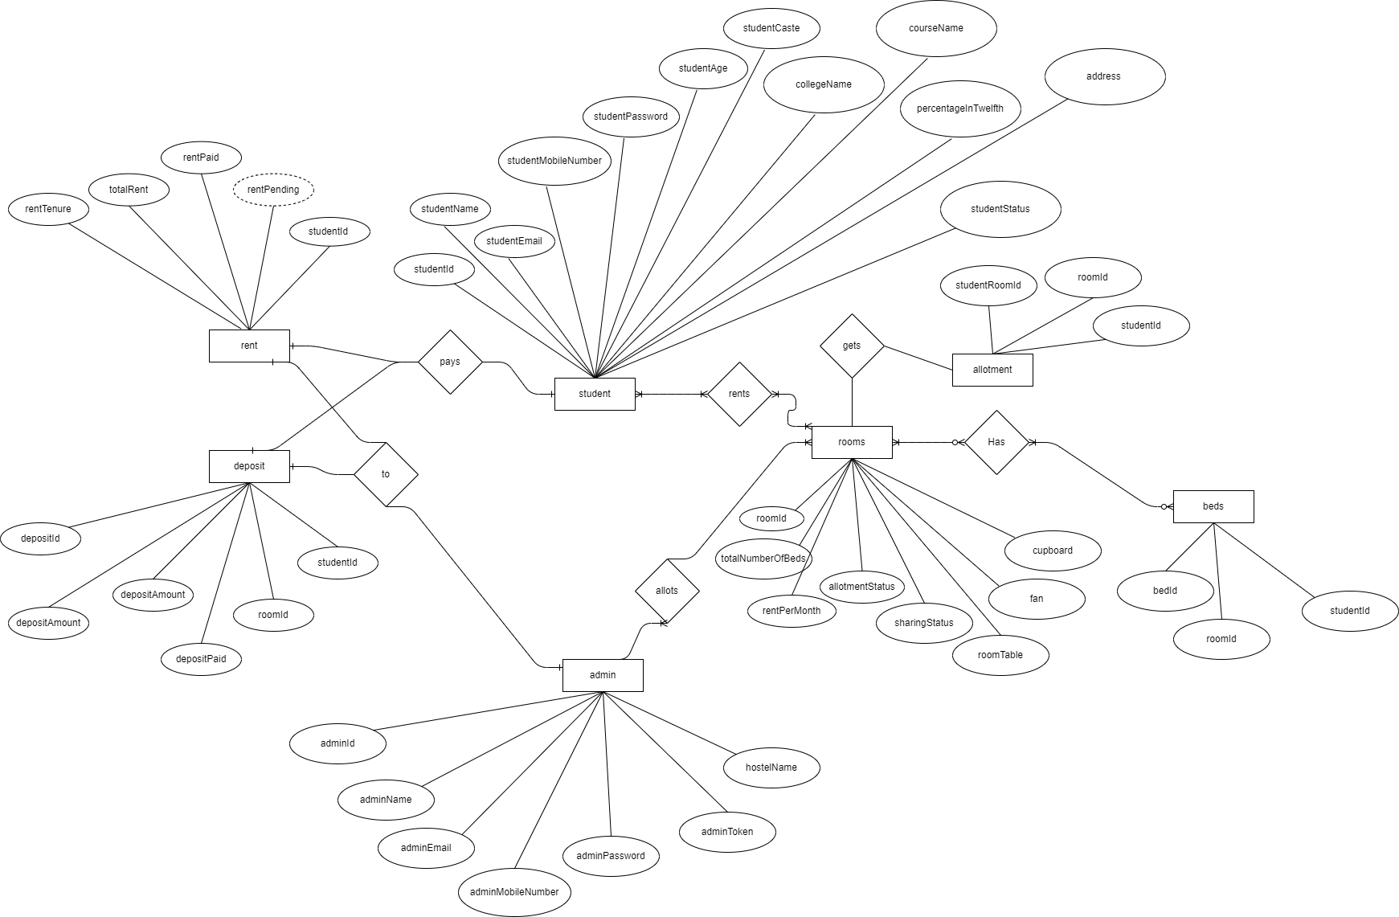

ADMIN USE CASE DIAGRAM
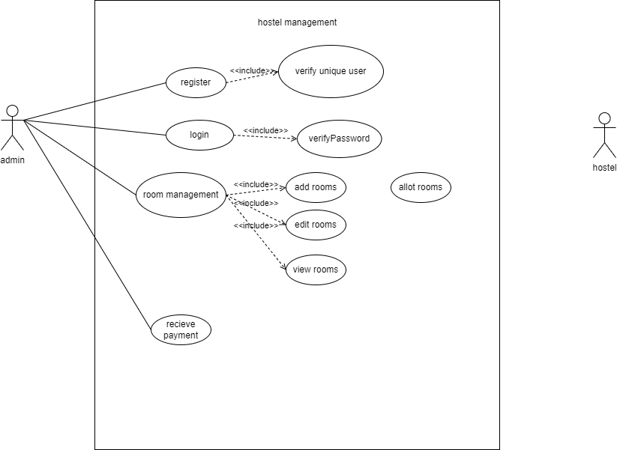

STUDENT USE CASE DIAGRAM

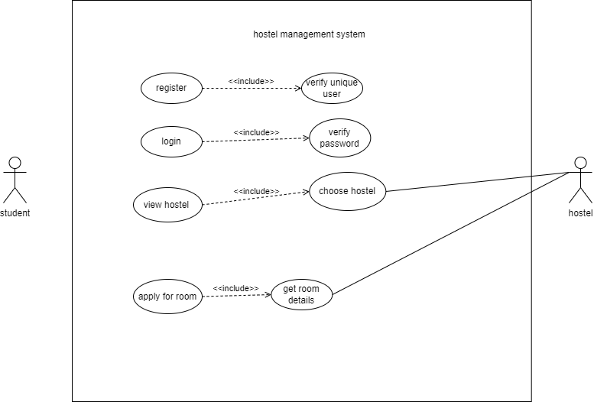

ACTIVITY DIAGRAM
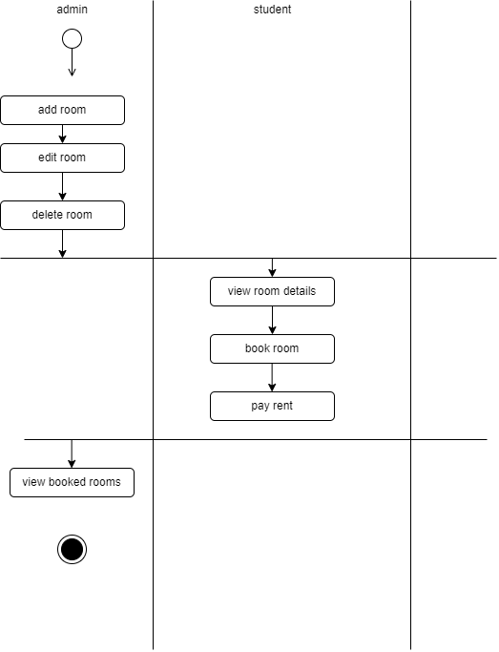

CLASS DIAGRAM

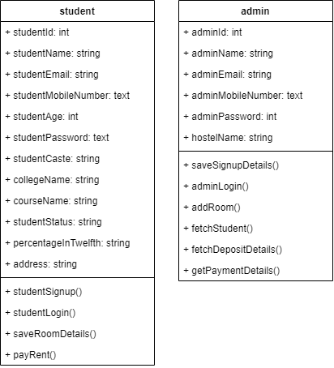

ADMIN SEQUENCE DIAGRAM

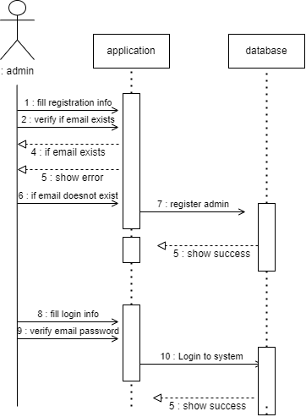

STUDENT SEQUENCE DIAGRAM

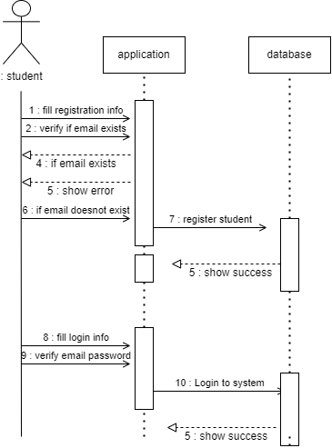

OUTPUT SCREENS

Admin Signup / Login

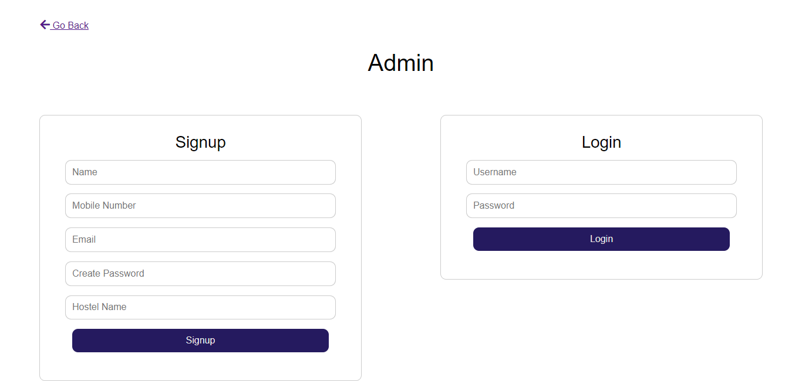
Admin Dashboard
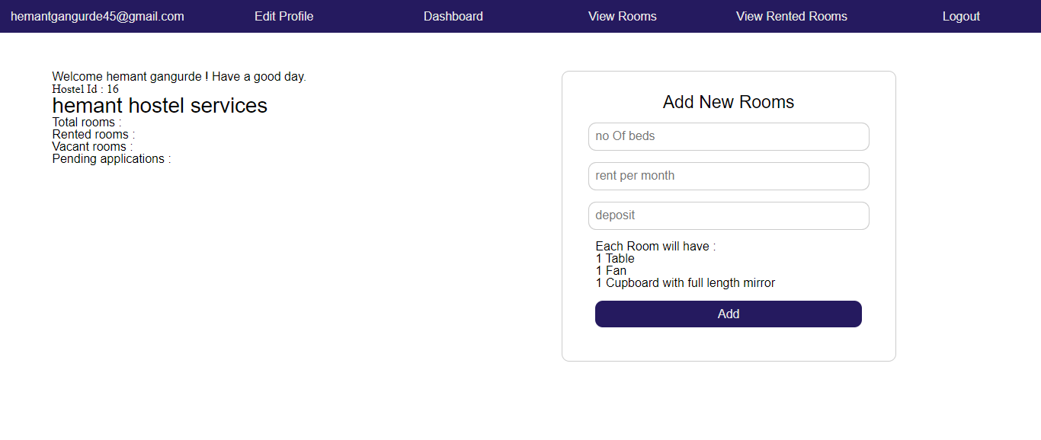

View rooms

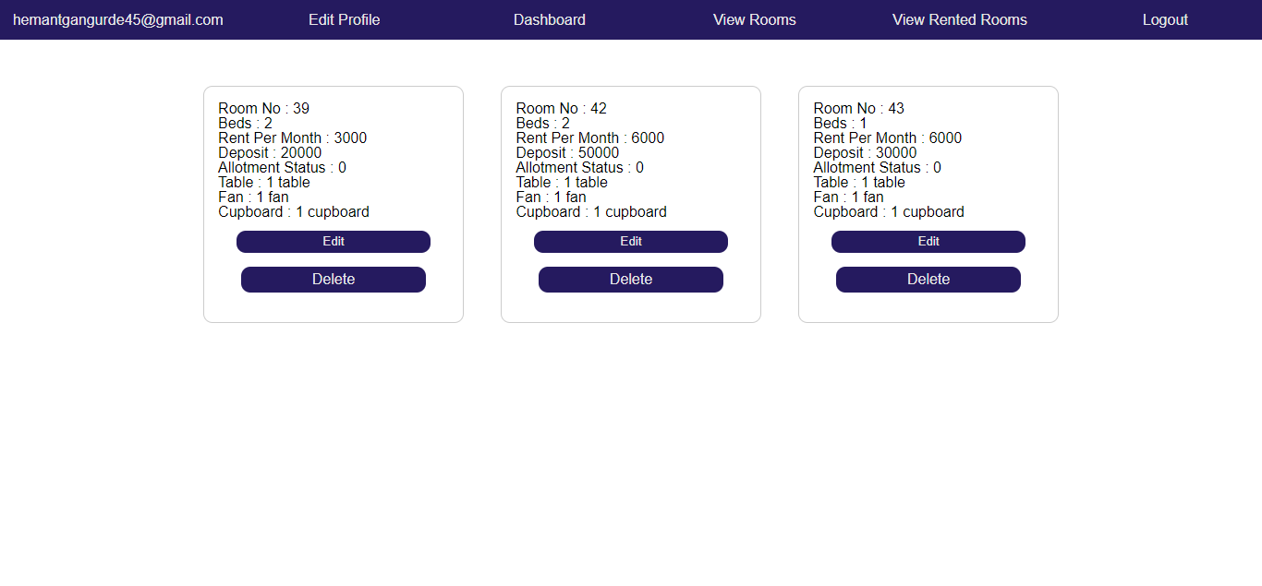
View rented rooms
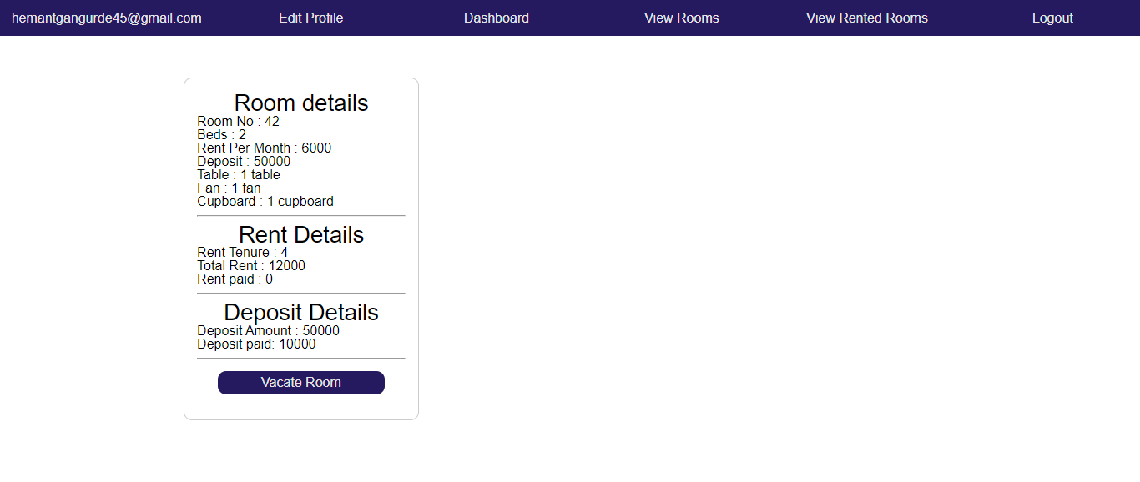

Hostel gallery
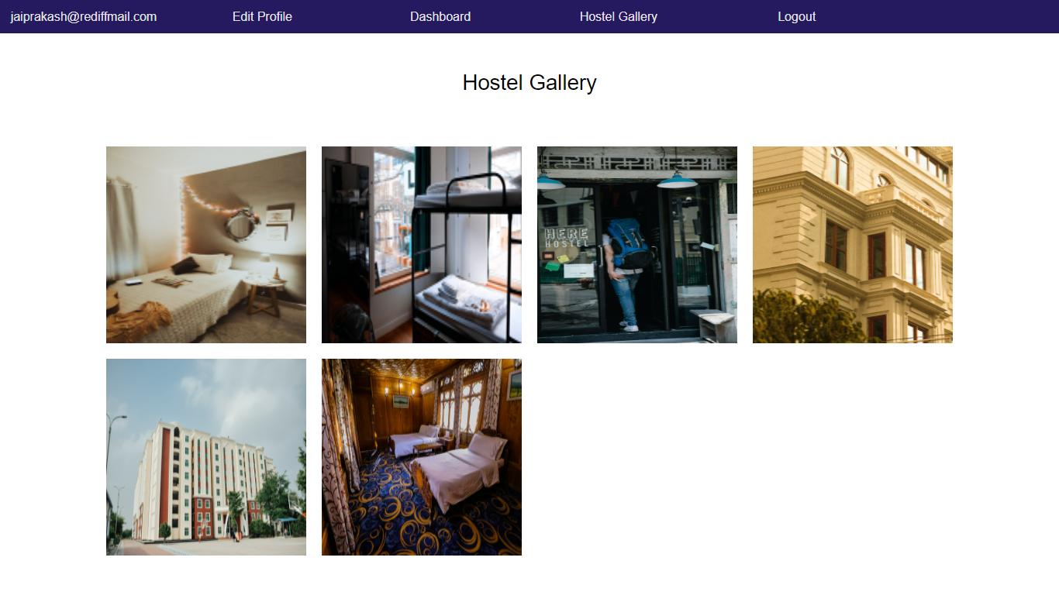

Student Signup / Login
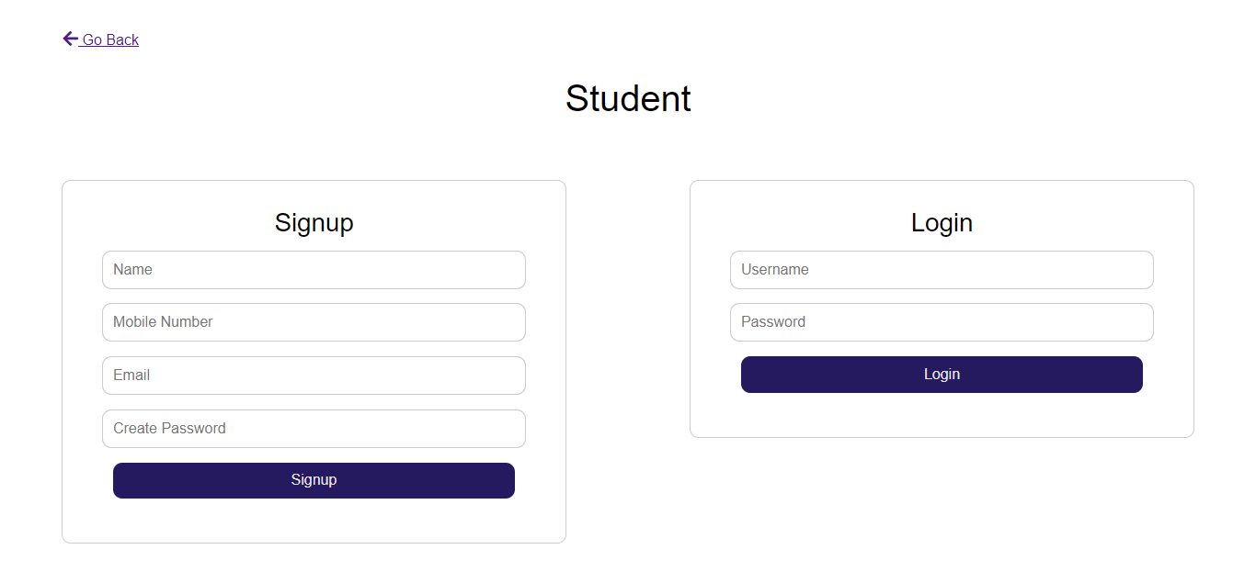

Student Dashboard
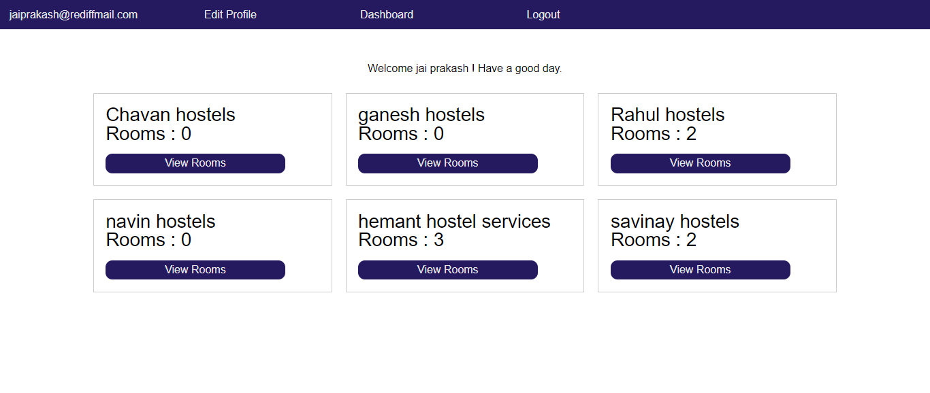
View hostels
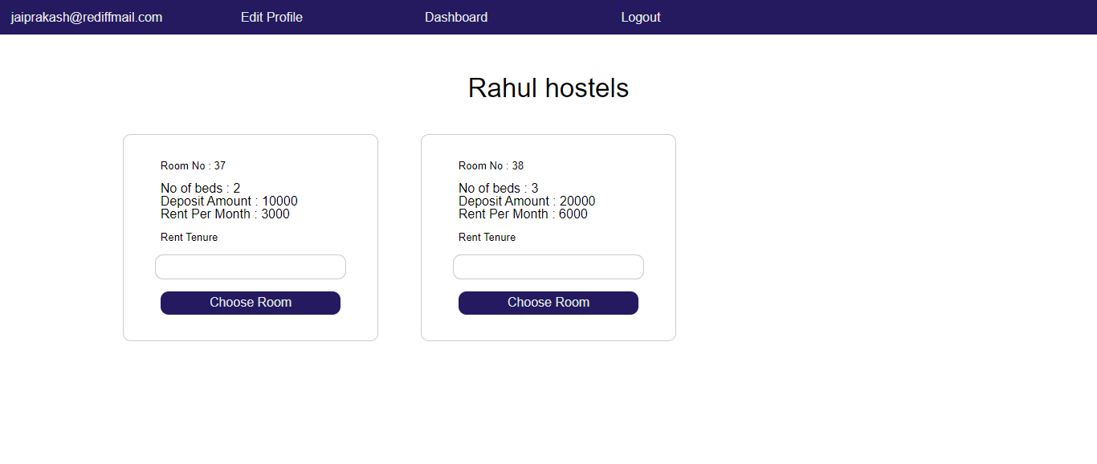

Book room
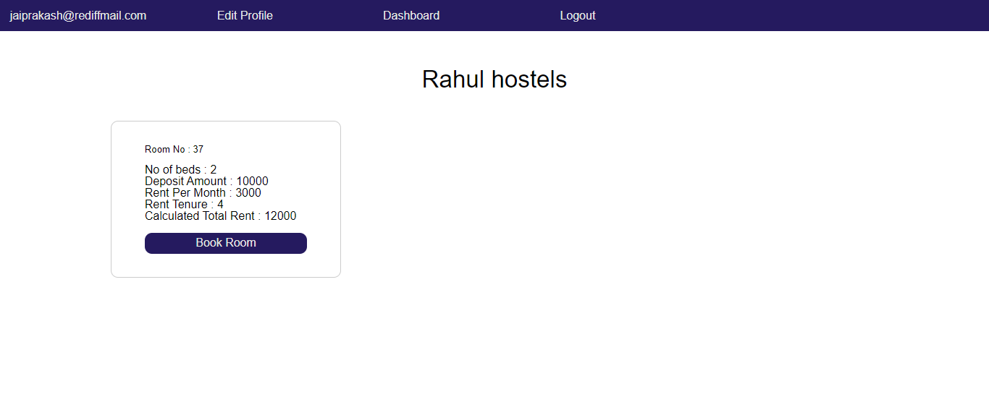

Edit profile
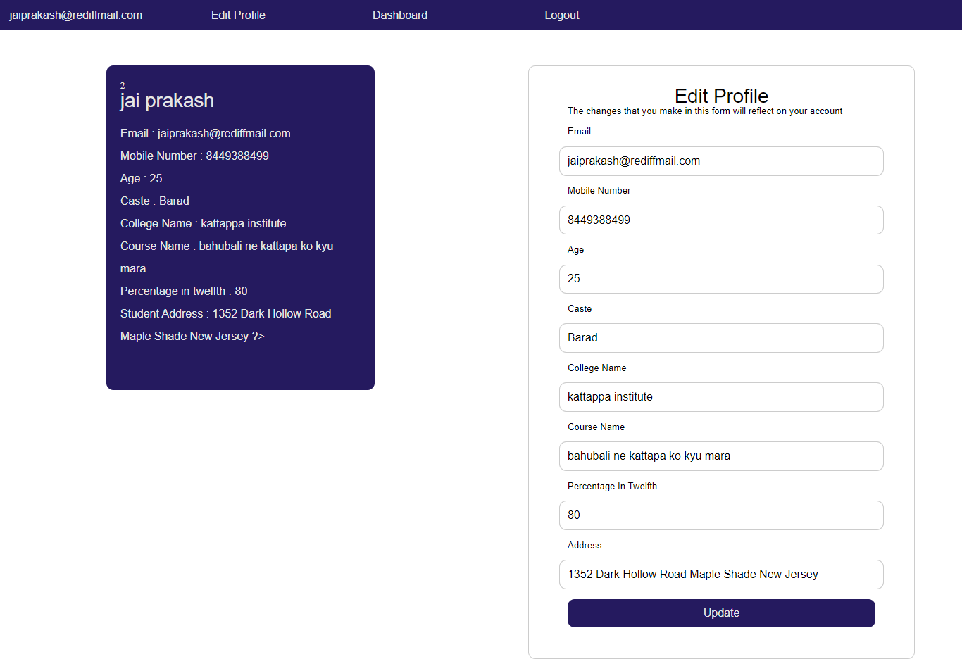

CONCLUSION

- This system would reduce the human errors.
- Usage of this system would greatly reduce time wasted in manual work.
- Accuracy of handling the data would improve.
- The volume of paperwork would be greatly reduced.
- Fast rate of operation as in providing bill.
- Flexibility of booking room from student’s place of choice.
- Better storage and faster retrieval system.
- Errors in the reports will be greatly minimized.

